What a difference a decade makes. Ten years ago this month, Yellowstone National Park was a sea of flames. Some of the largest wildfires in U.S. history swept across Yellowstone’s beautiful landscape, burning forests, and threatening buildings. Yellowstone, some people said, was ruined.
Yellowstone Makes a Triumphant Return Ten Years After Fires
By Bruce Babbitt

The following article is adapted from the Austin American – Statesman.

Night after night, terrible images of ash and flame flashed across America’s TV screens. One evening, after showing a huge expanse of blackened forest, network news anchor Tom Browkaw sadly concluded: “This is what’s left of Yellowstone tonight.”

But guess what? Fire didn’t destroy Yellowstone. Ten years later, we realize fire had the opposite effect. Fire actually helped Yellowstone. Elk and other wildlife are healthy. Tourism is thriving. Biodiversity is thriving. New forests are rising from the ashes of old ones. The recovery is so remarkable it deserves a closer look.

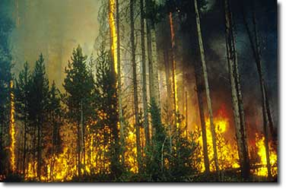
First, a bit of background: The 1988 fires were gigantic. They swept over approximately 793,000 of Yellowstone’s 2.2 million acres – one third of the park. Some were caused by lightning, others were started by humans. The $120 million fire-fighting effort against them has been called the largest in U.S. history. The heroic work saved many key buildings. But in the wild lands, it made almost no difference. What put Yellowstone’s fires out was not retardant-dropping planes or armies of firefighters on the ground. It was a quarter of an inch of autumn rain.

In July and August, as fires swept across the park, business owners became angry. Our future is ruined, they said. Tourism is dead. But today, tourism is very much alive. Yellowstone has set several visitation records since 1988. Fire has not stopped tourists; it has attracted them – just as it attracts many kinds of wildlife. Ten years later, the number one question asked of Yellowstone naturalists remains “What are the effects of the fires?”
The answer is simple: The fires were helpful.

Since 1988, more than seventy research projects have looked at different parts of the Yellowstone fires. Not one of them has concluded the fires were harmful. That sounds too good to be true. But it is. The science is there to prove it.
Come to Yellowstone and see for yourself. Pull off the road near Ice Lake. Here the fire burned especially harshly. Hundreds of thousands, perhaps millions, of mature pine trees were destroyed. But today, the forest floor is a sea of green – knee-high pine trees planted, literally, by the fires of 1988.

Yellowstone’s pine forest is a place of mystery. In order to live, it must first die. It must burn. The fire that swept through here worked an ancient truth. It baked the pinecones, melted their sticky resin, and freed the seeds locked inside. Within minutes, a new forest was planted.

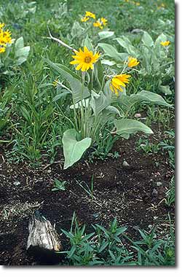
By stopping wildfire, as Smokey the Bear taught us to do, we upset nature’s cycles. We rob our forests of something they need desperately. We steal their season of renewal. Without fire, pine forests grow old, prone to disease, and unnaturally thick. There are lessons in these pines. Too much protection is no advantage.

Look closely around Ice Lake and you will almost surely see something else: wildlife. Bison, elk, mule deer, bighorn sheep, and mountain goats have all done well since 1988. Just as fire recharged the pines, so, too, did it help plants that grazing animals eat.

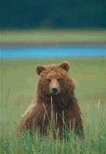
If you’re lucky, you may also see Yellowstone’s king of beasts: the grizzly bear. To a grizzly, wildfire is a meal ticket. Fires kill trees, which fall to the ground and fill up with insects: grizzly sushi. Others enjoy the feast, too. Before 1988, three-toed woodpeckers were almost gone from Yellowstone. After 1988, one scientist spotted thirty in one day. But dead pines are more than lunch counters; they are housing communities, home sites for mountain bluebirds, tree swallows, and other birds and animals.

Ten years ago, the news media said fire “blackened” Yellowstone. Today, we know the reverse is true. Fire has painted the park brighter, added color and texture to its ecosystem, and increased the variety and abundance of its plant and animal life.

Facts
- The summer of 1988 was the driest in the Park's recorded history.
- More than 793,000 acres (36% of the park) were affected by fire.
- Fires begun outside of the park burned more than half the total acreage.
- Humans caused 9 fires; lightning caused 42 fires.
- $120 million was spent and 25,000 people participated in this firefighting effort, the largest in U.S. history.
- Rain and snow finally stopped the advance of the fires in September.

